FaceGuard AI – Tasks & Definition of Done
Oct 20, 2026 · @Hoan
Each member owns one task from research to a trained, evaluated model running in the web app. Code freezes on Nov 15, 2026. The video and reports are done by Nov 22, 2026, and we submit on Nov 23, 2026, two days before the Nov 25, 2026 deadline.

Roles at a glance
Face recognition has two owners because the brief requires two approaches and it sets the threshold the app uses.
Member | Owns | Hands to the team
Hoàng Hữu Hoan (lead) | Anti-spoofing; shared notebook template, checkpoint storage, weekly review, Canvas submission | Best liveness model + metrics; final submission
Giáp Hoàng Gia Khánh | Face recognition Model A (classification), optional Model C (ArcFace) | Model A checkpoint + embeddings + results
Lê Đức Anh | Face recognition Model B (triplet loss) + verification evaluation script | Model B checkpoint; shared ROC/AUC script; final face threshold
Trần Mạnh Đức | Emotion detection | Best emotion model + metrics
Lê Đức Thành | Datasets, shared face crop + data loaders, spoof recording sessions, group report | Clean data on Drive; src/common/; compiled report
Nguyễn Nam Khánh | Web app and end-to-end integration | Working webcam app with registration and attendance log

Timeline
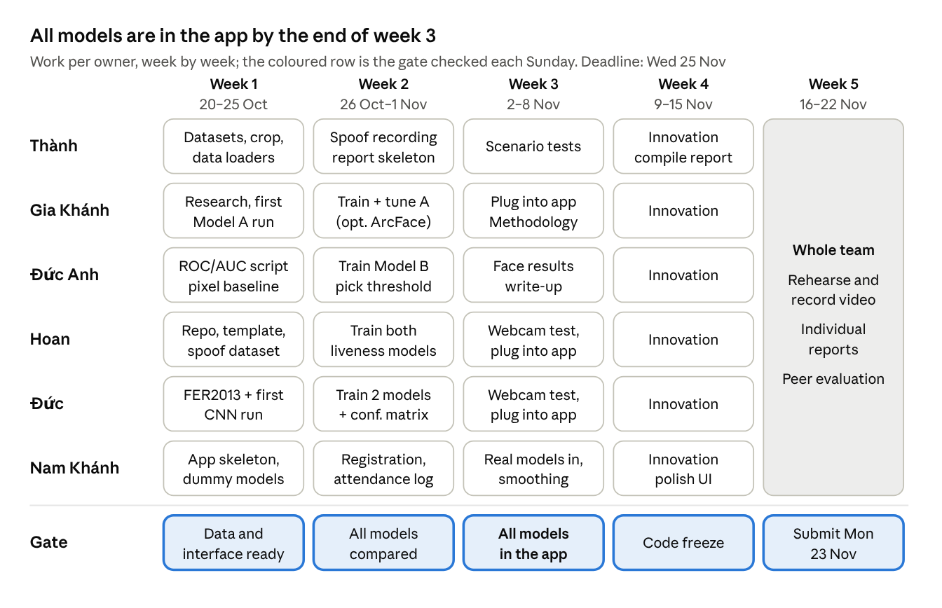
Week-by-week plan · 6 owners, 5 gates
Everyone works in parallel from week 1, so nobody waits on training. Week 5 is shared by the whole team. Weeks run Monday to Sunday, and each gate is checked at that Sunday's call.

Rules for every task
A task is done only when it meets its own criteria below and every rule in this section.
Shared setup (agreed in week 1)
- One framework for everyone: PyTorch. Train on Colab or Kaggle GPUs, each owner on their own account.
- One face-crop function in src/common/, used for training and in the live app.
- Every model exposes the same interface so the app can plug it in:
detector.detect(frame) -> list[box]
embedder.embed(face) -> np.ndarray # L2-normalised
liveness.predict(face) -> (label, prob)
emotion.predict(face) -> (label, probs)
- Checkpoints go in the shared Drive folder, named <task>_<model>_<date>.pt.
- Train your own models. Code from papers or GitHub is fine as a reference (cite it); downloaded trained weights are not a final model. ImageNet weights as a starting point should be fine (confirm with the tutor, see Open questions).
Team-wide definition of done
- Code is merged to main through a pull request reviewed by one other member.
- A README section says how to train and how to run inference.
- Results (table + figures) are saved in reports/figures/ and the owner's Methodology, Results and Discussion paragraphs are in the report draft.
- The model runs inside the web app through its predict() function.
- The owner can explain the model, loss, data and results without notes (interview prep).

Thành — data, preprocessing, group report
Thành makes sure every owner trains on clean, correctly prepared data and that the report comes together on time.
Tasks
- ☐ Week 1: download the Kaggle face datasets for all tasks
- ☐ Week 1: explore each dataset (number of classes, images per class, image size, class balance) and share a one-page summary
- ☐ Week 1: build the shared face-crop function in src/common/ and test it on webcam frames and dataset images
- ☐ Week 1: write the PyTorch data loaders: classification, triplet (P identities × K images per batch), emotion, liveness
- ☐ Week 1–2: run spoof recording sessions — every member records real-face, printed-photo and phone-screen clips
- ☐ Week 2: create the group report skeleton (Methodology, Results, Discussion) in Google Docs
- ☐ Week 3: run the scenario tests on the integrated app and log failures
- ☐ Week 4: compile the group report from each owner's sections; check the 12-page limit
Done when
- Each owner can load their training data with one import and confirms it works.
- The same crop function is used in training and in the app (checked by Nam Khánh).
- The recorded spoof dataset has at least 6 people × 3 conditions (real, print, phone), split into train and test by person.
- The scenario test log covers: registered person, new person, printed photo, phone screen, each emotion, poor lighting, two people.
- The group report is ≤ 12 pages, includes every owner's section, and has been read by all six members.

Gia Khánh — face recognition, Model A (classification)
Gia Khánh trains the classification baseline: a CNN that learns to classify training identities, whose second-to-last layer becomes the face embedding.
Tasks
- ☐ Week 1: read 1–2 references on softmax-based face embeddings; write down the expected AUC range
- ☐ Week 1: agree the shared backbone with Đức Anh (proposed: ResNet-18, ImageNet weights, adapted to the dataset's image size)
- ☐ Week 1: first training run on train_data
- ☐ Week 2: tune (learning rate, augmentation, embedding size); report accuracy on val_data and test_data
- ☐ Week 2: export embeddings and run Đức Anh's verification script with cosine and Euclidean
- ☐ Week 2 (optional): Model C with ArcFace loss on the same backbone, as the "additional approach"
- ☐ Week 3: wrap the best model as embedder.embed(face) and hand it to Nam Khánh
- ☐ Week 3: write the Methodology paragraph (backbone, loss, hyperparameters, training scheme)
Done when
- Model A is trained on the same data, backbone and input size as Model B, so the comparison is fair.
- Classification accuracy on val_data and test_data is reported.
- AUC on verification_pairs_val.txt is reported for cosine and Euclidean, with ROC curves.
- The checkpoint is on Drive and embed() returns an L2-normalised vector in under 50 ms on a laptop CPU.
- If Model C is attempted, it is in the same results table; if not, the report says why.

Đức Anh — face recognition, Model B (triplet) + verification evaluation
Đức Anh trains the metric-learning model and owns the script that scores every face model, so all face results are measured the same way.
Tasks
- ☐ Week 1: build the verification script — read verification_pairs_val.txt, embed both images, score with cosine and Euclidean, output ROC curve, AUC, and the threshold at a chosen false positive rate
- ☐ Week 1: run it on raw flattened pixels to get a "no learning" baseline AUC for the report
- ☐ Week 1: read 1–2 references on triplet loss and hard-negative mining
- ☐ Week 1–2: train Model B on the shared backbone with triplet loss (batch-hard or semi-hard mining, margin about 0.2–0.3)
- ☐ Week 2: produce the final comparison: every face model × {cosine, Euclidean}, one AUC table and one ROC figure
- ☐ Week 2: choose the best model + metric, and the app threshold (e.g. at FPR ≈ 1%)
- ☐ Week 3: write the Methodology paragraph for Model B and the similarity-metric comparison
Done when
- The verification script runs on any checkpoint with one command and is used for Models A, B (and C).
- The baseline, Model A and Model B AUCs are in one table, with ROC curves on one figure.
- The chosen model, metric and threshold are written in the README and given to Nam Khánh.
- The report explains why the winning model and metric won, not only that they did.

Hoan — anti-spoofing + team lead
Hoan trains the liveness model that stops printed photos and phone screens, and keeps the team on schedule.
Anti-spoofing tasks
- ☐ Week 1: choose two candidate models (proposed: MobileNetV2 fine-tuned vs a small CNN from scratch)
- ☐ Week 1: define the recording protocol for Thành's sessions (distance, lighting, which phones and prints)
- ☐ Week 2: train both candidates on public + recorded data; evaluate on a held-out set of people
- ☐ Week 3: test the best model live on the webcam; retrain with more recorded data if it fails
- ☐ Week 3: wrap it as liveness.predict(face) and hand it to Nam Khánh
- ☐ Week 3: write the Methodology paragraph
Lead tasks
- ☐ Week 1: set up the GitHub repo, shared Colab/Kaggle notebook template, and the Drive checkpoint folder
- ☐ Week 1: update the signed group agreement with these roles
- ☐ Every Sunday: run the check-in; tick off this doc; flag anything behind
- ☐ Week 5: upload the video (YouTube unlisted or OneDrive) and check the link opens when logged out; submit source code, group report and video link on Canvas by Mon 23 Nov
Done when
- Both candidates are compared in one table: accuracy, APCER, BPCER, ACER.
- The test set contains people who are not in the training set.
- In the live app, a printed photo and a phone screen are both shown as "Spoof" and never logged as attendance.
- All deliverables are submitted, and every member has confirmed they read the final report.

Đức — emotion detection
Đức trains the model that labels each face with an emotion (happy, sad, angry, surprise, neutral, fear, disgust) shown as an icon in the app.
Tasks
- ☐ Week 1: confirm the dataset (FER2013: 48×48 grayscale, 7 classes) and two candidates (proposed: small custom CNN from scratch vs ResNet-18 fine-tuned)
- ☐ Week 1: first training run with the custom CNN
- ☐ Week 2: train both candidates; handle class imbalance (class weights or oversampling for "disgust")
- ☐ Week 2: evaluate on the FER2013 test split: accuracy, confusion matrix, per-class F1
- ☐ Week 3: test live on the webcam; decide whether to show all 7 classes or a reduced set, and record why
- ☐ Week 3: wrap the best model as emotion.predict(face) and hand it to Nam Khánh, with an icon for each label
- ☐ Week 3: write the Methodology paragraph
Done when
- Both candidates are compared in one table; the best reaches about 60–70% test accuracy (typical for FER2013).
- The confusion matrix is in reports/figures/ and the report explains the most-confused pairs.
- Live on the webcam, a clear smile shows "happy" and a neutral face shows "neutral" for each of the six members.
- The app's labels are stable (smoothed over several frames), not flickering every frame.

Nam Khánh — web app and integration
Nam Khánh builds the webcam app that runs all three models together, starting in week 1 with dummy models so integration never waits on training.
Tasks
- ☐ Week 1: pick the stack (proposed: Flask + OpenCV streaming to a local web page; Streamlit as the fallback)
- ☐ Week 1: webcam loop + face detection + dummy embed, liveness.predict, emotion.predict showing placeholder labels
- ☐ Week 2: registration flow — capture about 10 frames, average the embeddings, save them with the name
- ☐ Week 2: attendance log (name, time, emotion, liveness) in SQLite or CSV, one entry per person per session
- ☐ Week 3: plug in the real models in this order: liveness → recognition → emotion
- ☐ Week 3: smooth predictions over the last 5–10 frames; run heavy models every N frames if speed drops
- ☐ Week 3: write the system-architecture section and diagram for the report
- ☐ Week 4: polish the UI — live view, register dialog, attendance table, emotion icons
Done when
- One command starts the app on a laptop and it runs at about 10 frames per second or more.
- A registered person sees their name; an unknown person is asked to register and is recognised right after.
- A spoof never reaches recognition and is never logged.
- Name, liveness and emotion show at the same time on the live view.
- Any model can be swapped by replacing its checkpoint, with no app code changes.

Whole team — innovation, video, reports
- ☐ End of week 3: each member names their innovative feature here; no two the same
- ☐ Week 4: each feature built on its own branch behind an on/off switch, so it cannot break the demo
- ☐ Sun 15 Nov (end of week 4): code freeze on main
- ☐ Week 5: write the video script (5–10 min, about 1 min each, speaker's face visible) and rehearse twice
- ☐ Week 5: record the video in one continuous take, no edits
- ☐ Week 5: each member writes their individual report (≤ 5 pages: contribution, methods, challenges, innovative feature)
- ☐ Week 5: each member submits their individual report and peer evaluation
Done when the video shows every function (recognise, register, spoof rejected, emotion, attendance log, six innovative features) and everything is on Canvas by Mon 23 Nov, two days before the Wed 25 Nov deadline.

